Project Development Phase
2nd pdf- Dashboard screenshot, story screenshot along tableau public links
Date | 30 JUNE 2026
Team ID | SWTID-2026-1795
Project Name | HEART DISEASE ANALYSIS
Maximum Marks

Dashboard screenshot:
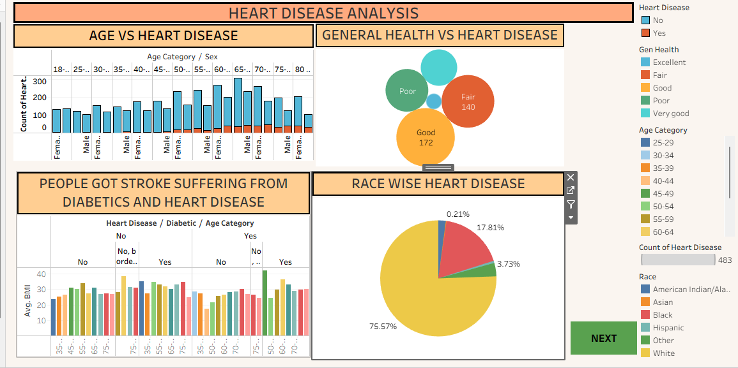
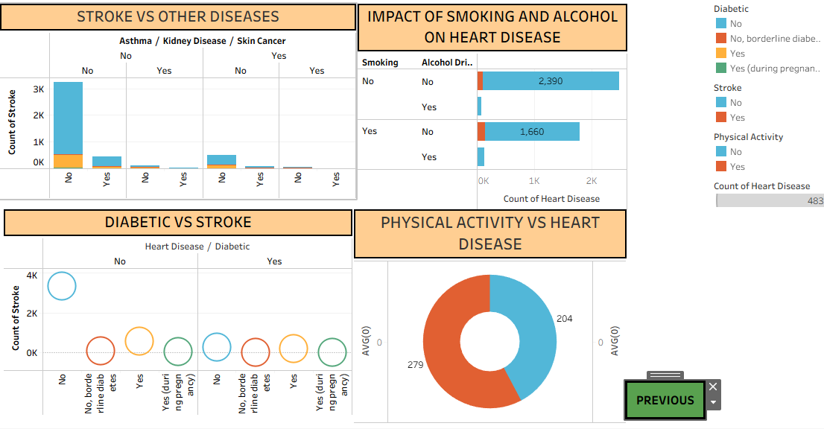
story screenshot:
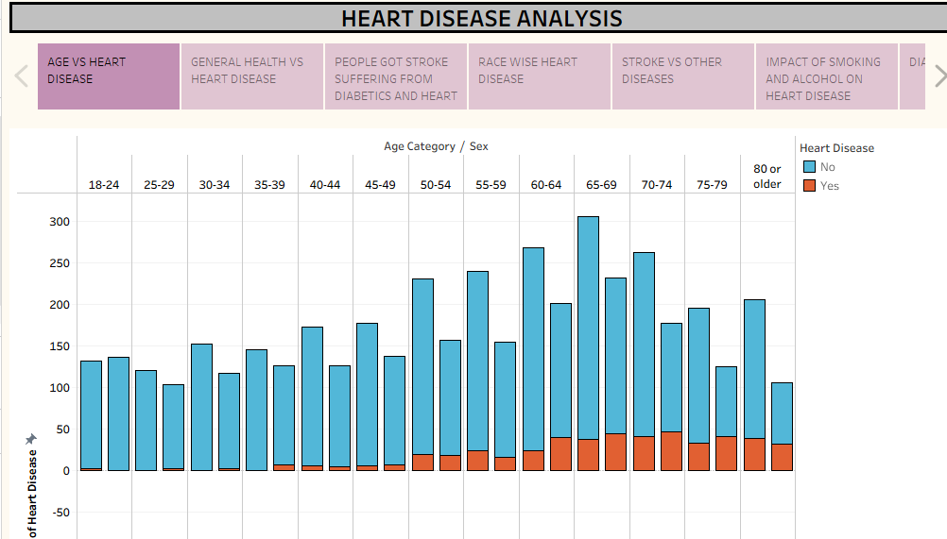

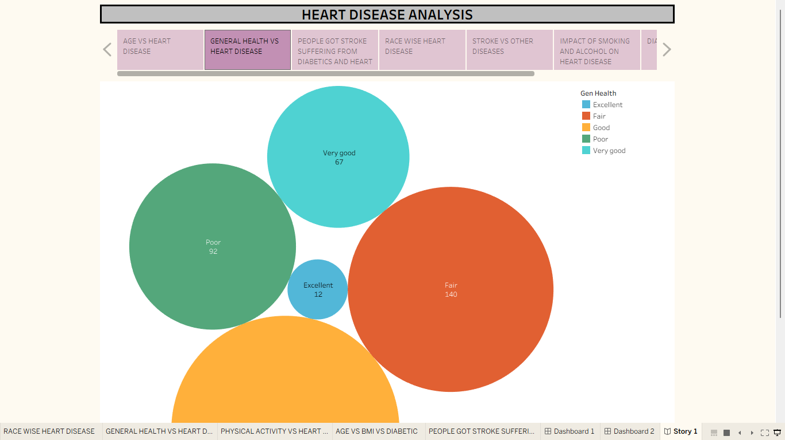

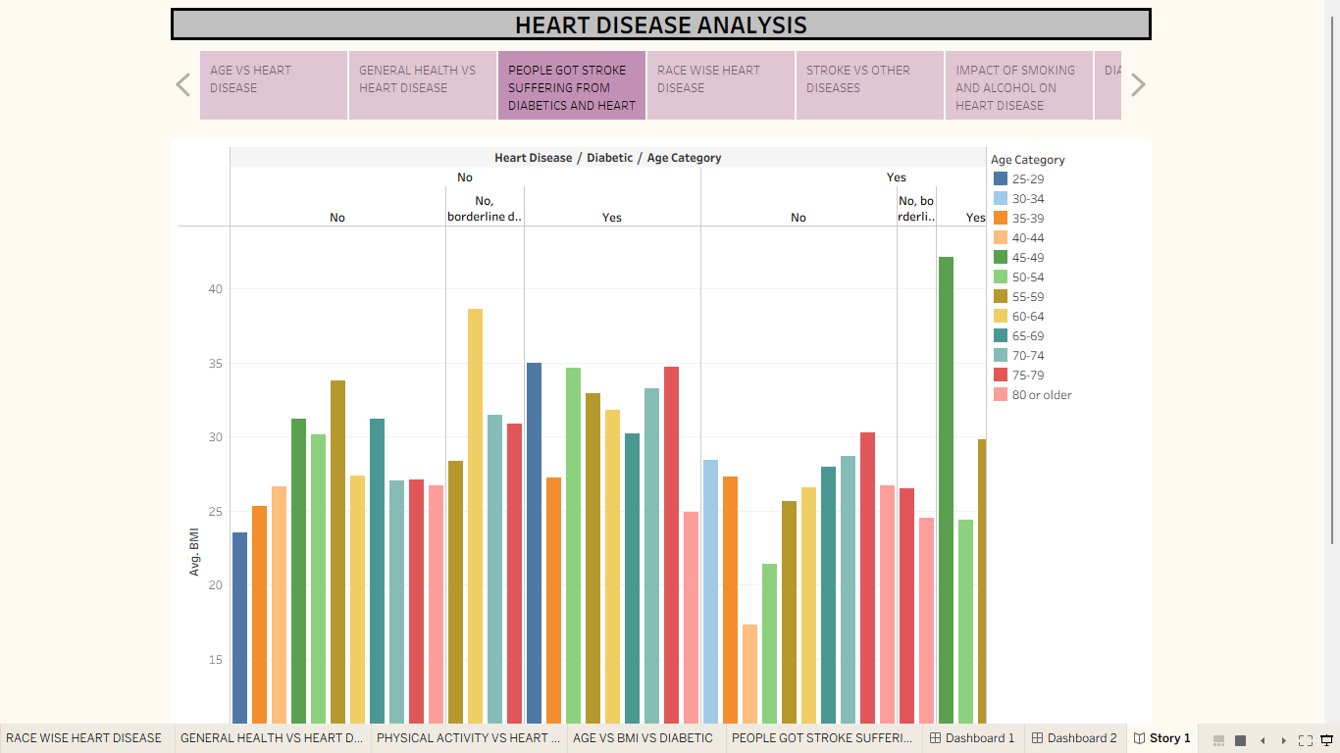
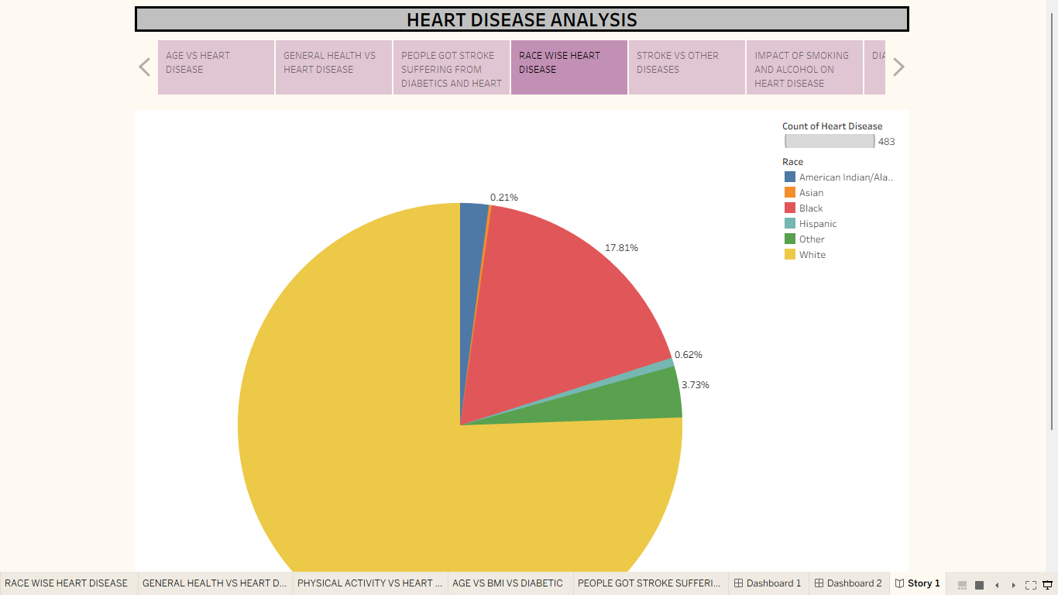

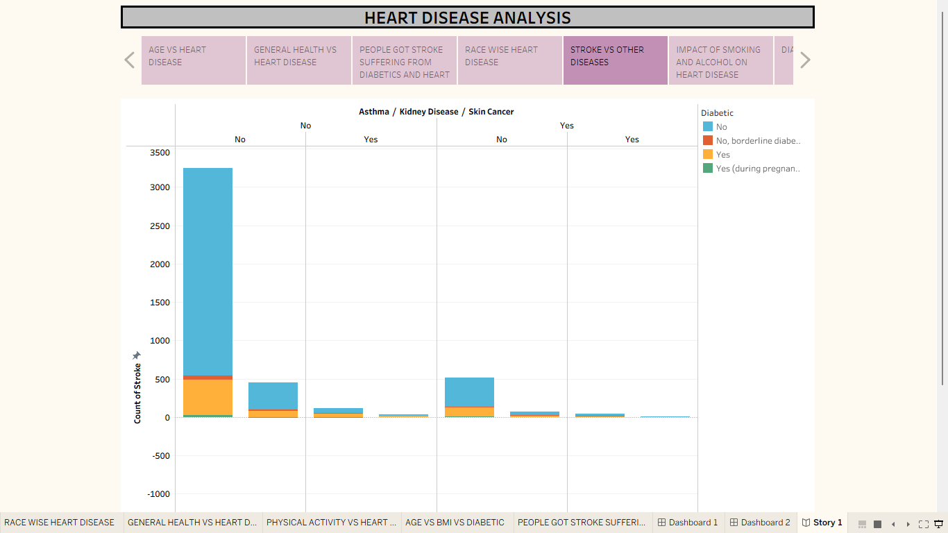

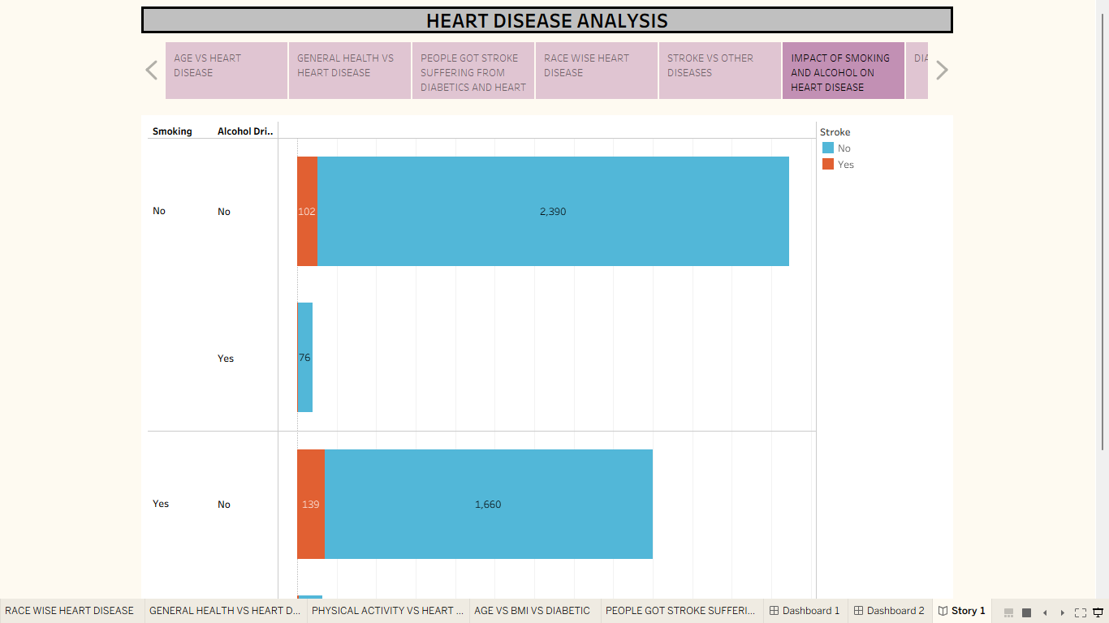

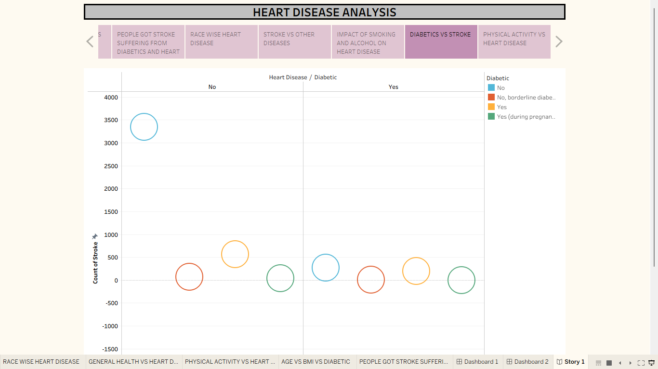

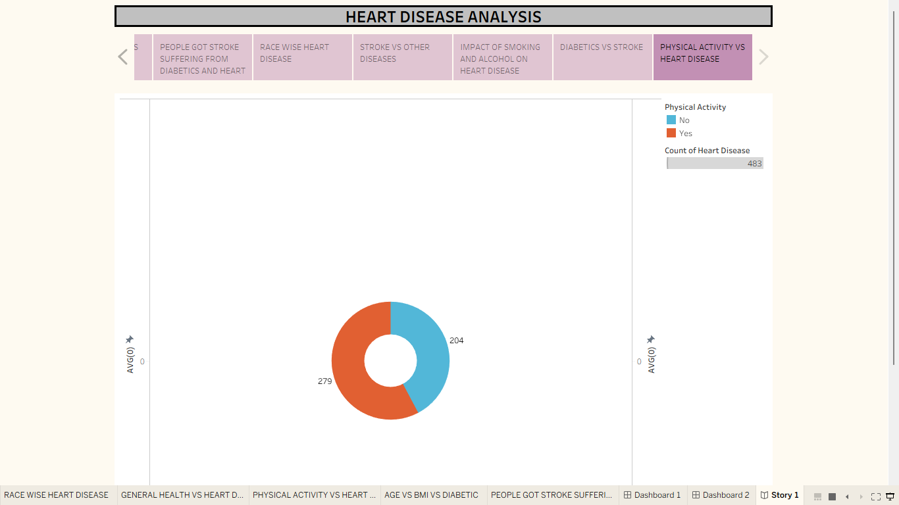

tableau public links:
dashboard link:
https://public.tableau.com/views/HEARTDISEASE_17827311709820/Dashboard1?:language=en-US&:sid=&:redirect=auth&publish=yes&showOnboarding=true&:display_count=n&:origin=viz_share_link

story link:
https://public.tableau.com/shared/2B42RRKJS?:display_count=n&:origin=viz_share_link

